**System Hacking**

***Internship Project From Talakunchi Networks***

1. **Using Hydra Tool:-**

🡪Hydra is an built in tool in kali-linux os,

It is used to crack the password and get into the system.

🡪The syntax for the usage of the command :-

**$ hydra -L [user_name_file_path] -P [passwords_file_path] open_port // target_ip**

🡪And to get the open port of the target use ‘nmap scanning’.

🡪In our case the target ip is my metasploitable machine.

* Target ip:-

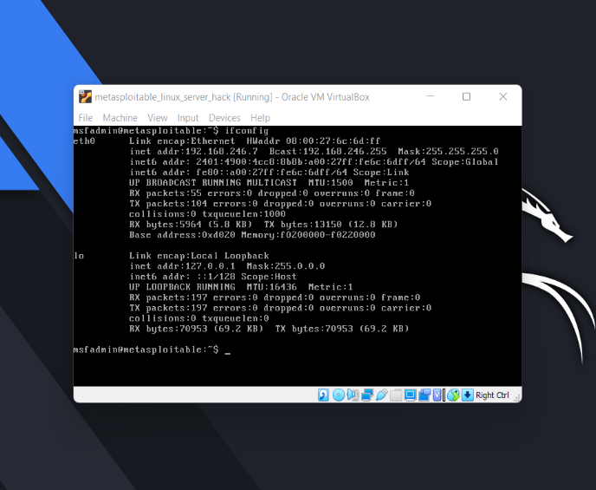

🡪the target ip is :-192.168.246.7

* Performing N-map scanning to get the open port information:-

🡪$ nmap -sS 192.168.246.7

🡪The following are the open port’s in our target machine.

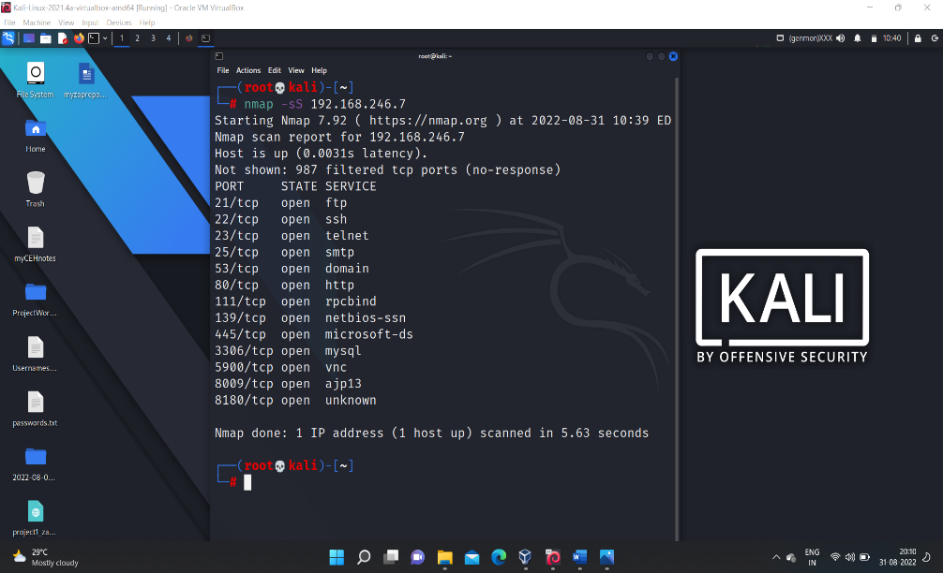

🡪Then now using the ‘hydra’ exploiting the open port to get into the target machine.

🡪**consider username file and password file.**

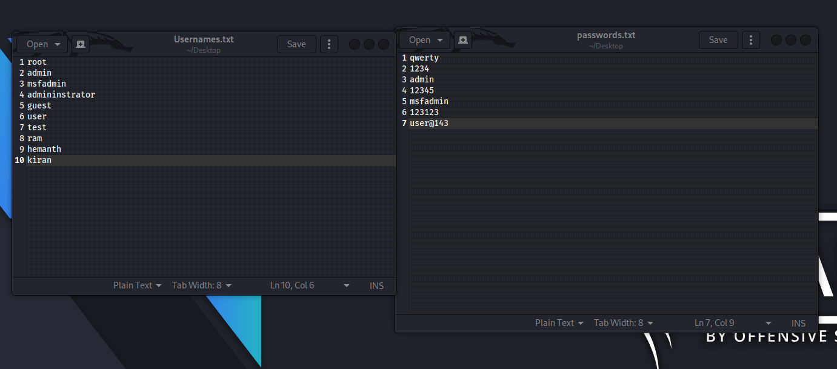

🡪Now let us perform the exploitation on one of the open port shown in the above screenshot (say ‘ssh’)

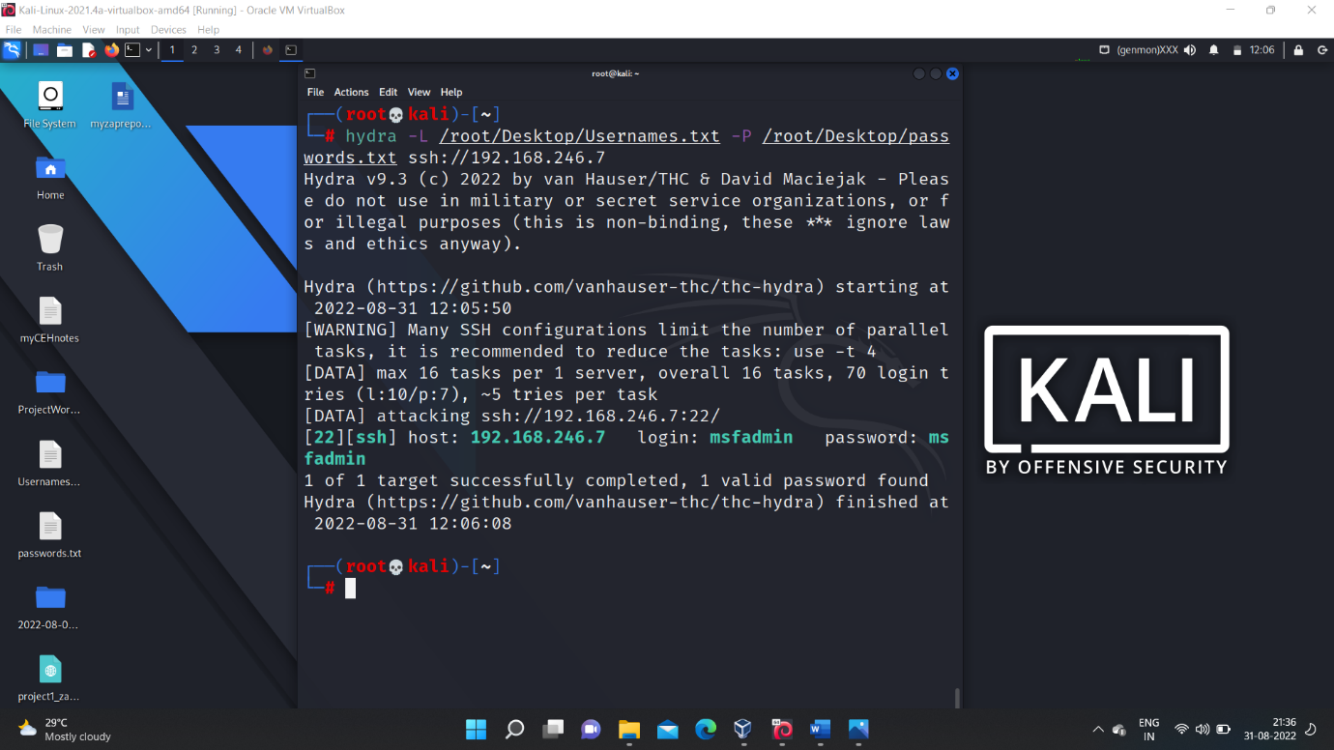

🡪After exploiting we get the login credentials which is shown in above screenshot.

🡪we can perform it on any open port of the target machine let us consider another port (say ‘ftp’)

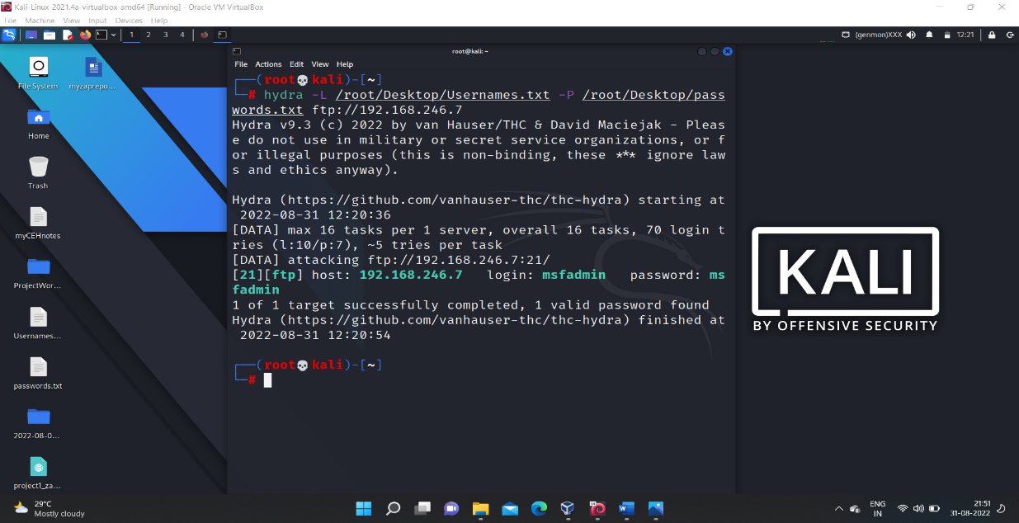

🡪This is all about system hacking using ‘hydra’ tool.

1. **Using Auxiliary :-**

-->auxiliary modules are under the metasploit frame- work which is an built-in tool available in the kali-linux os.

-->first find the open port details of the target machine in our case it is metasploitable machine

--> Target ip :- 192.168.246.7 -->open ports are:-

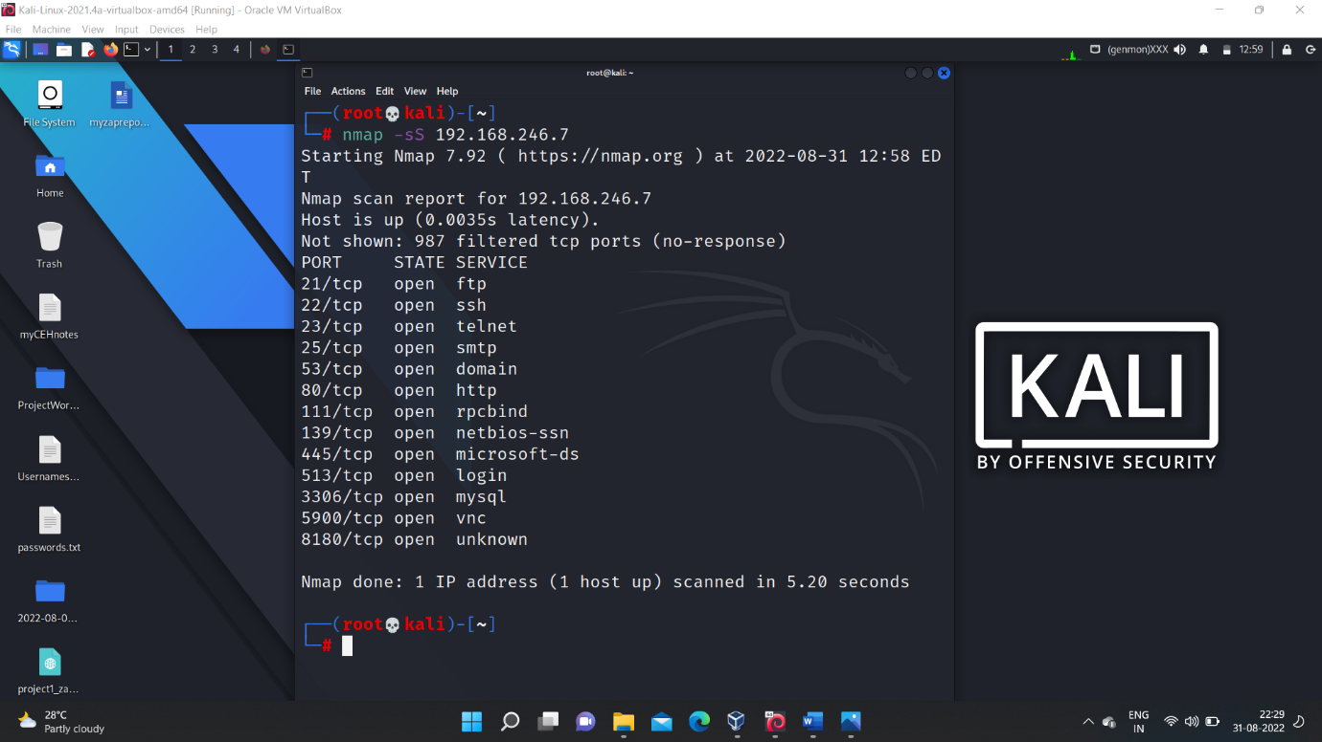

🡪Then get into the metasploitable frame work using the command **$ msfconsole**

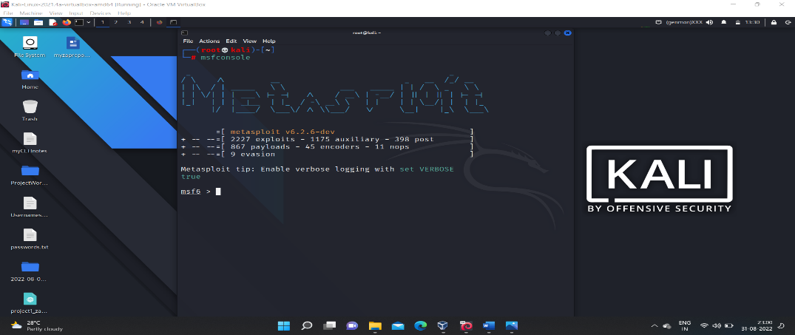

🡪then based on which open port you want to exploit the target machine choose the corresponding ‘auxiliary module’

🡪for example if you want to exploit based on the ‘ftp port’ then select corresponding ‘auxiliary module’

**$ use auxiliary scanner/ftp/ftp_login**

**🡪**then on using the command $ show options.

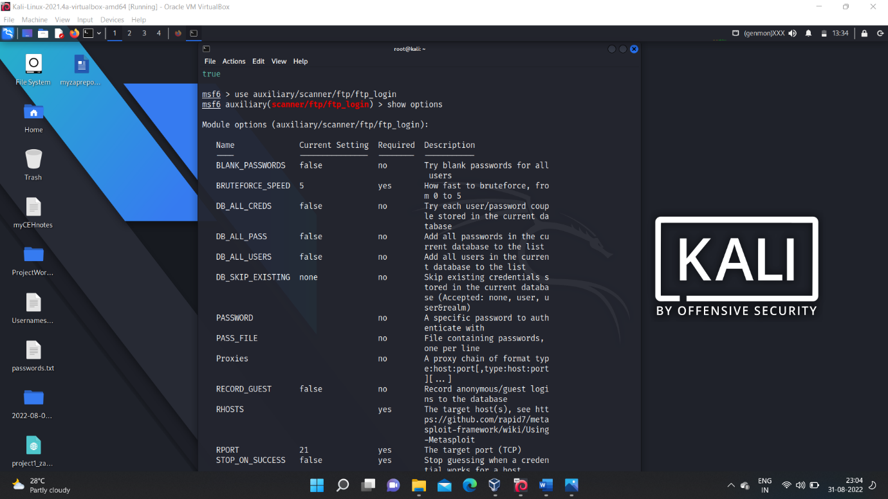

🡪then set the required fields with the values like

for (user_file and pass_file setting their respective file paths )and setting (rhosts = target_ip),(setting verbose = false ,will help to prevent showing the task involved in exploitation) and setting (stop_on_success = true)

🡪then after setting all those values then use the command **$ run** to start exploitation.

🡪after the exploitation completion we get the login credentials.

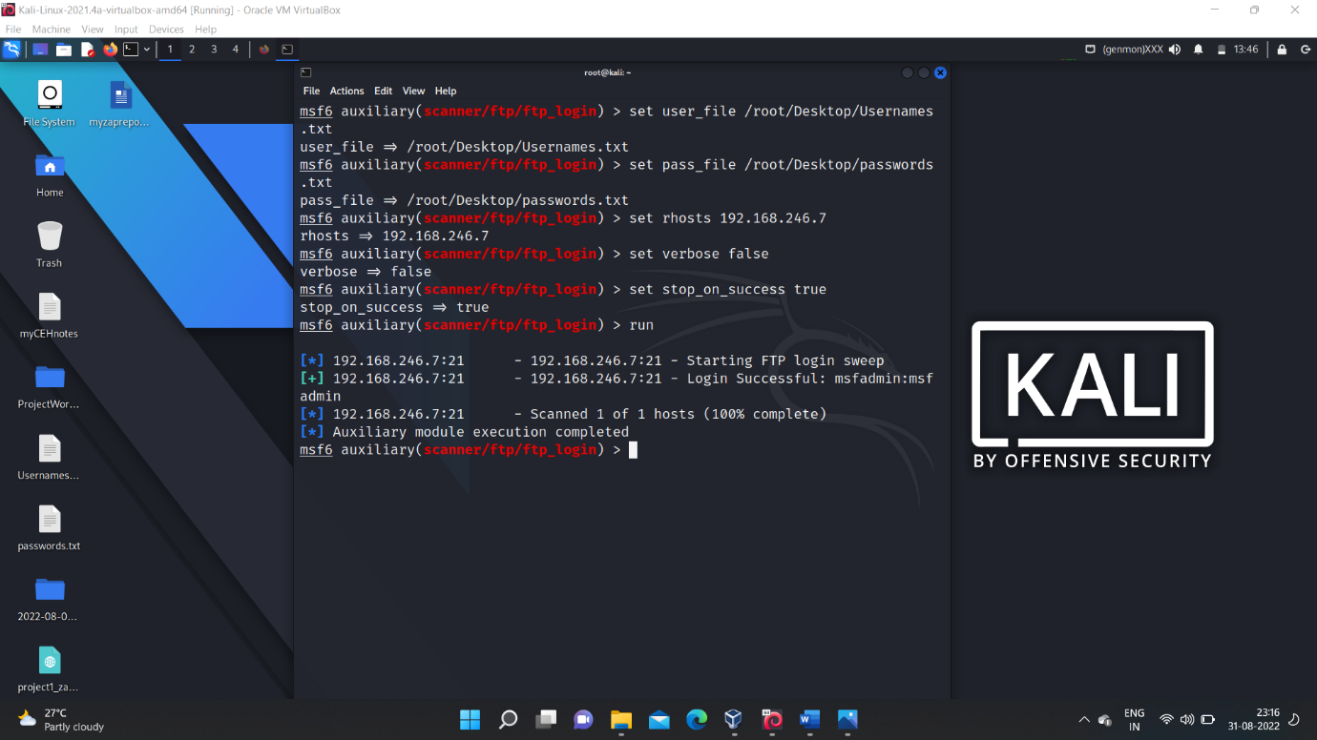

🡪similarly we can do with any another open port also (say ‘ssh’)

🡪it involves:-

**$ use auxiliary scanner/ssh/ssh_login**

🡪setting the required values as show for the ‘ftp’ above.

🡪then **$ run** to start exploitation.

🡪then we get the login credentials.

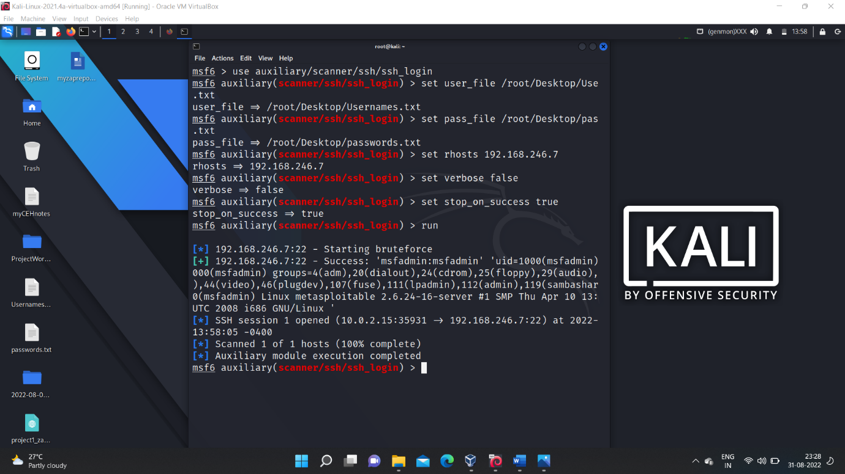

🡪After getting the login credentials we can login into the target system through the gained access through the session.

🡪**$ session -i 1**  to get an interactive session with the target system and we can perform any action.

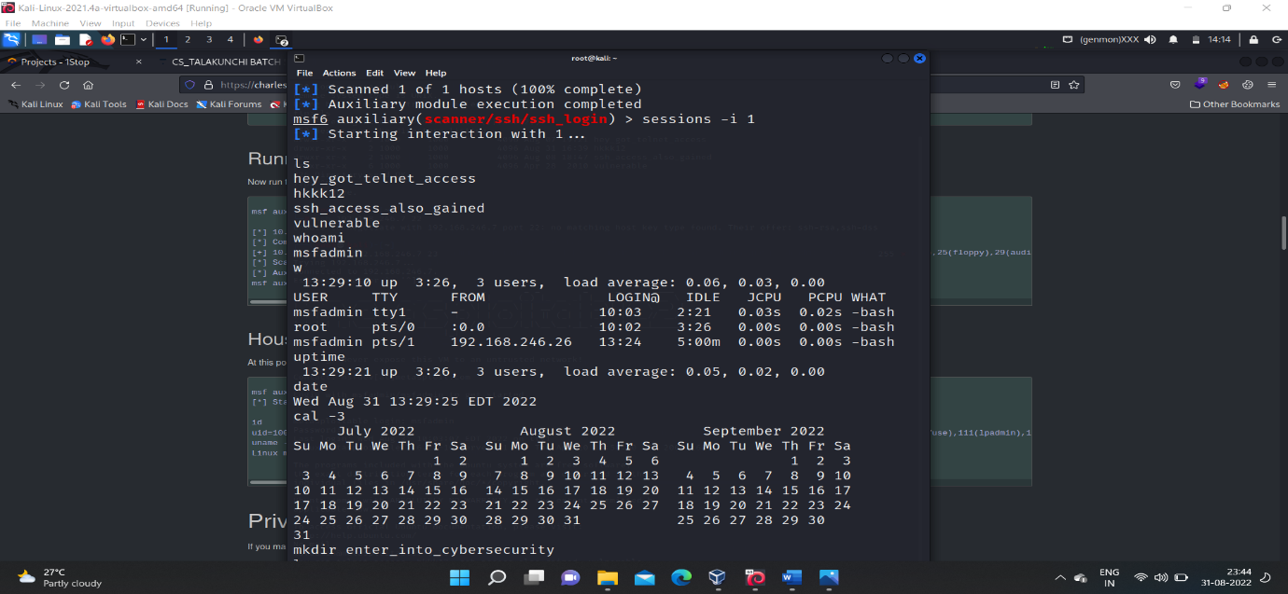

🡪This is all about system hacking using auxilixary modules.

1. **Using NSE – Scripts :-**

🡪The ‘NSE-scripts’ are also known as ‘automated scripts’ or ‘nmap scripts’ these are the built in scripts in the ‘kali-linux’ os and it doesn’t require any file as input like ‘user_name or password_file’ .

🡪The scripts itself contains all the required thing to perform an bruteforce activity on the open port of the target machine.

🡪target_ip : - in our case it is ‘metasploitable machine’. --> 192.168.246.7

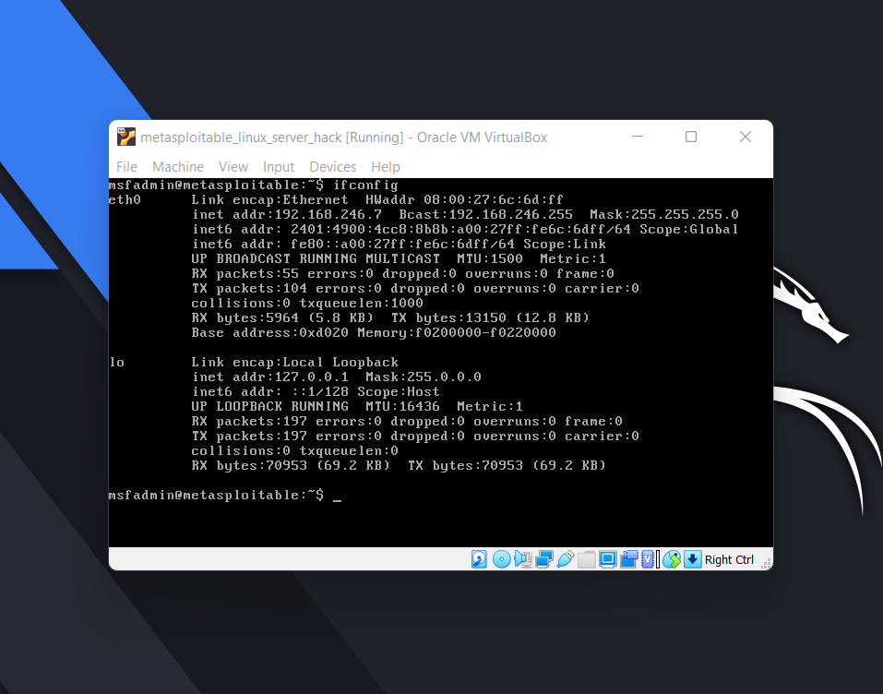

🡪Then find the open ports on the target machine using the command.

$ nmap -sS 192.168.246.7

* It gives the information of the list of open ports on the target machine.

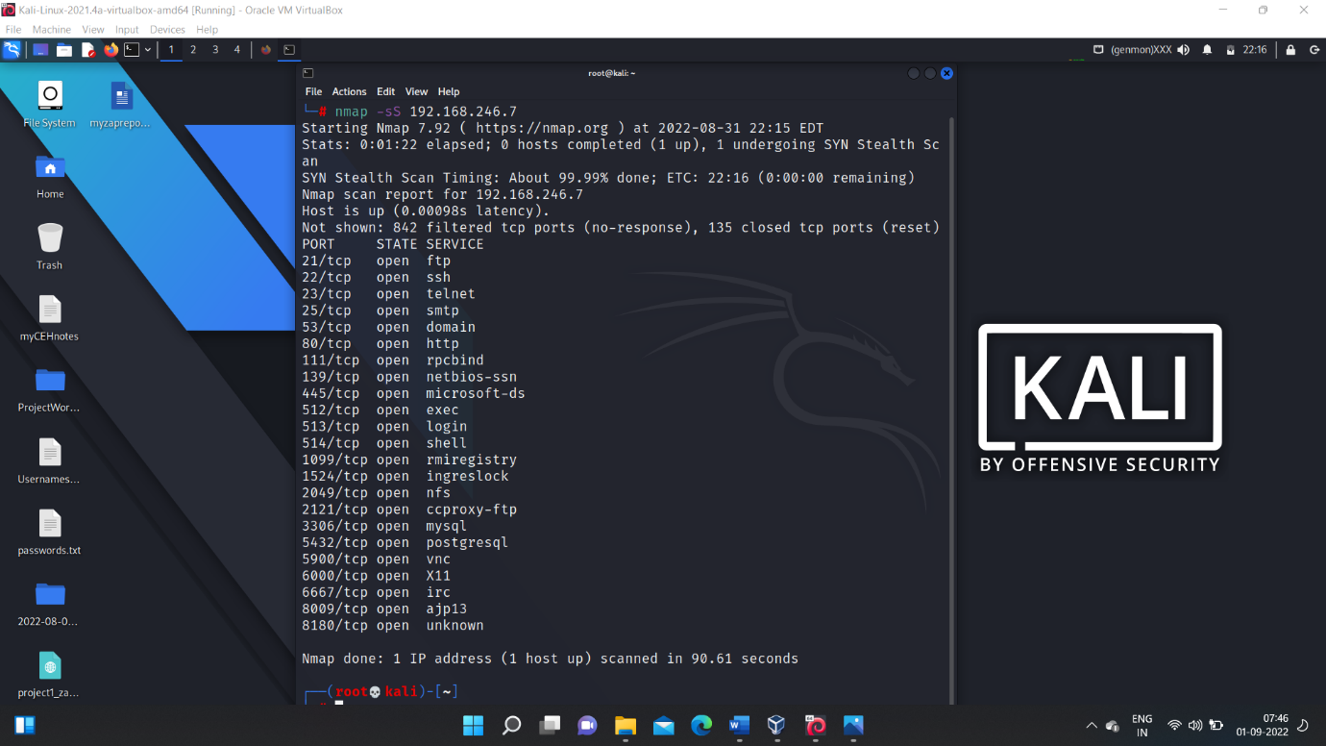

* Select one of the open port and load the corresponding ‘-brute.nse’ script and the start exploiting.
* Steps involved in exploiting using ‘nse-scripts’:-
* (1) navigate to the location where the ‘nse-scripts’ are located.

$ cd /usr/share/nmap/scripts

* Then when we give ‘ls’ we will find so many scripts in that location.
* Then choose the script that is corresponding to the open port(let say ‘ssh’) on which you want to exploit target machine.

**$ ls -l | grep ssh**

* Then you can find the corresponding ‘ssh’ nse scripts, from that choose the ‘ssh-brute.nse’ to exploit the target machine.

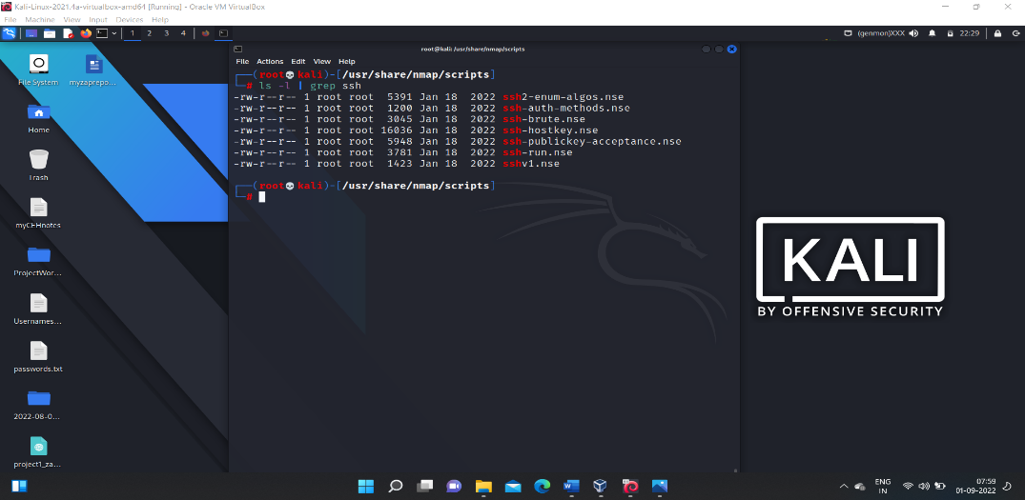

* Command to load the selected script .

**$ nmap --script ssh-brute.nse -p 22 target_ip**

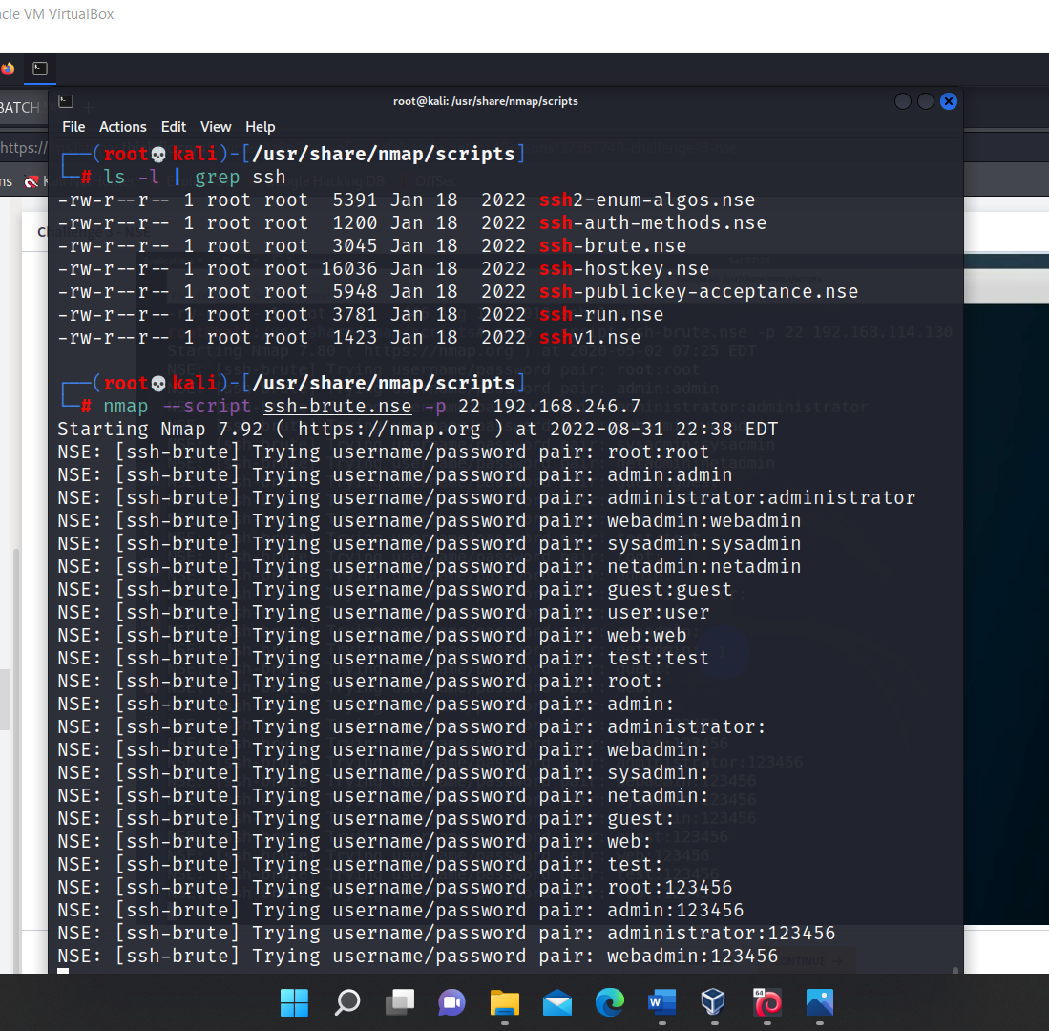

>Then the script performs exploitation on the target-

machine with the ‘username’ and ‘password’ pairs it contains and it takes few minutes of time to perform the exploitation with all those pairs and it gives the credentials after finding the correct ‘user_name and password ‘pair

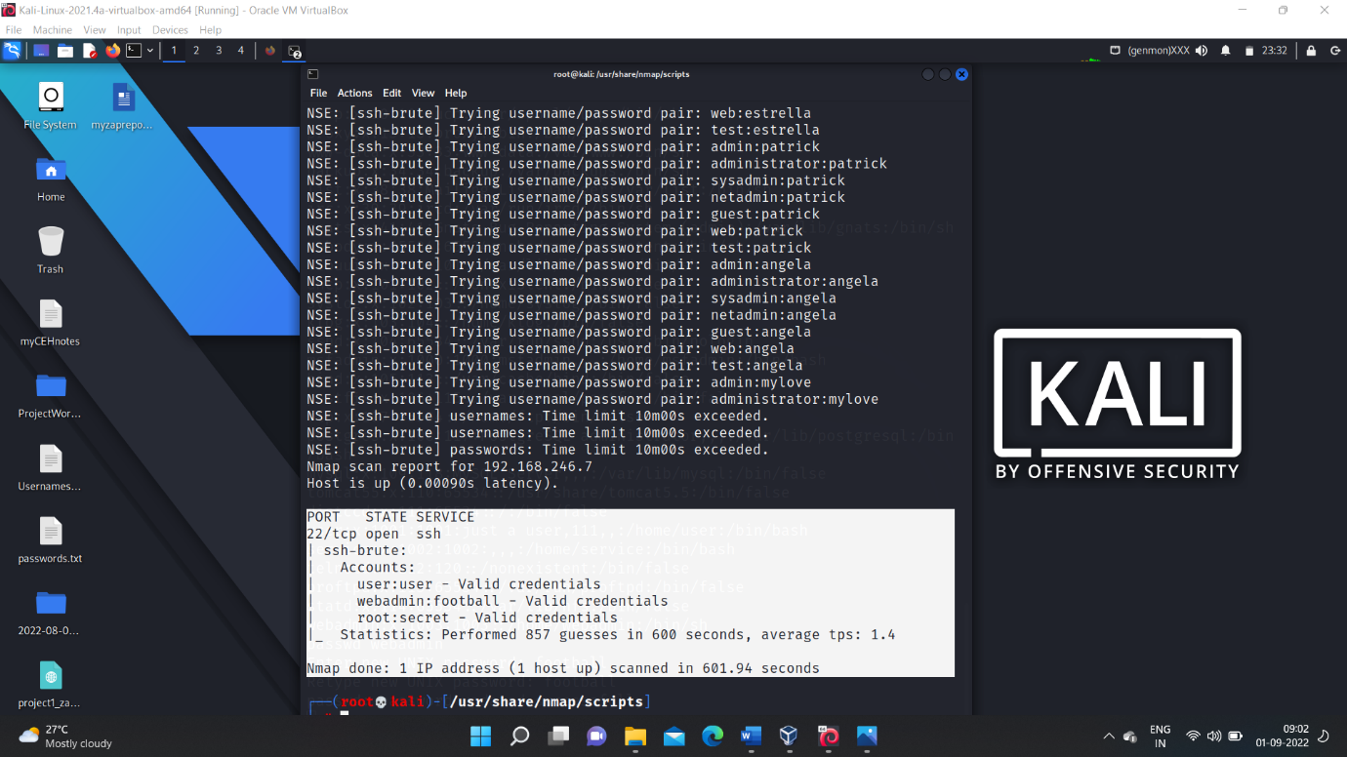

>from above exploitation we get 3 valid user credentials they are:-

**> user : user**

**> webadmin : football**

**> root : secret**

>Then we can able to login into the target machine and we can perform any actions.

>This is all about the system hacking using ‘nse-scripts’.

**(4) Using John The Ripper:-**

‘John the ripper’ is a password cracking tool, the greatness of the ‘John’ is that it cracks the passwords that is even stored in ‘hash value’.

* Working of john:-

By default John maintains an dictionary of password and it’s hash value .

> when we give the file containg the username and the password in hash .

> john checks the given hash values with the hash value present in its dictionary if matches then it gives the out put as the ‘username’:

its_corresponding_password.

**Lets see practically:-**

Lets us crack the password for the users in our kali-linux who’s passwords are stored in the ‘/etc/shadow’ file as hash values.

🡪 To prove that we cracked the passwords of users.lets us first create some users with some different passwords.

🡪lets create some users

$ sudo useradd user_name

🡪it is the command used to create an user.

Let us consider our users and their password:-

‘ram’ : 123456

‘new_user’ : qwerty

‘theActor’ : password

🡪after creating the above users with their passwords, their username and their passwors(in hashvalue) are stored in ‘/etc/shadow’

🡪screen shot showing user creation.

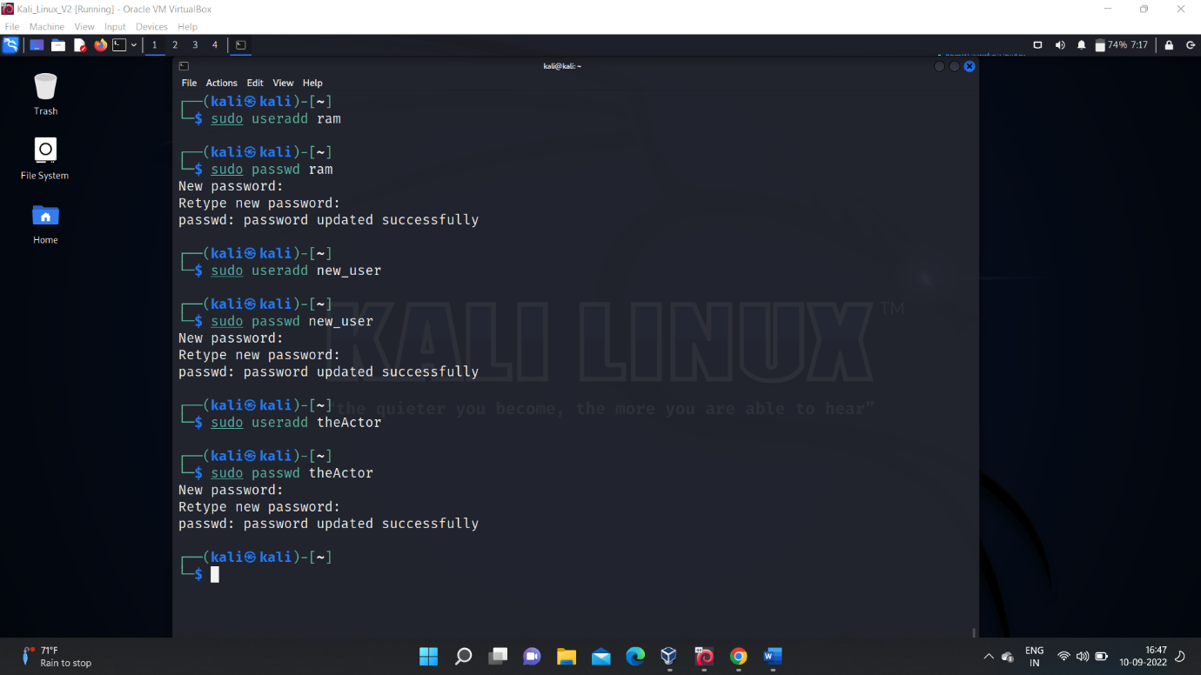

🡪Above user details in ‘/etc/shadow’ file.

$ cat /etc/shadow

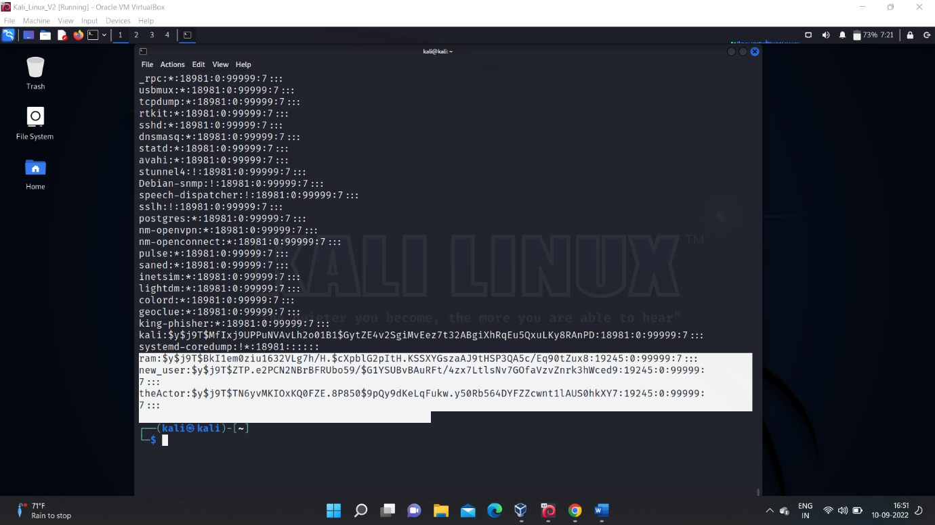

>Now lets load the hash values of ‘/etc/shadow’ into john and crack the passwords.

* command for that:-

$ sudo john --format=crypt /etc/shadow

>It takes some time and cracks the passwords and shown as an output.

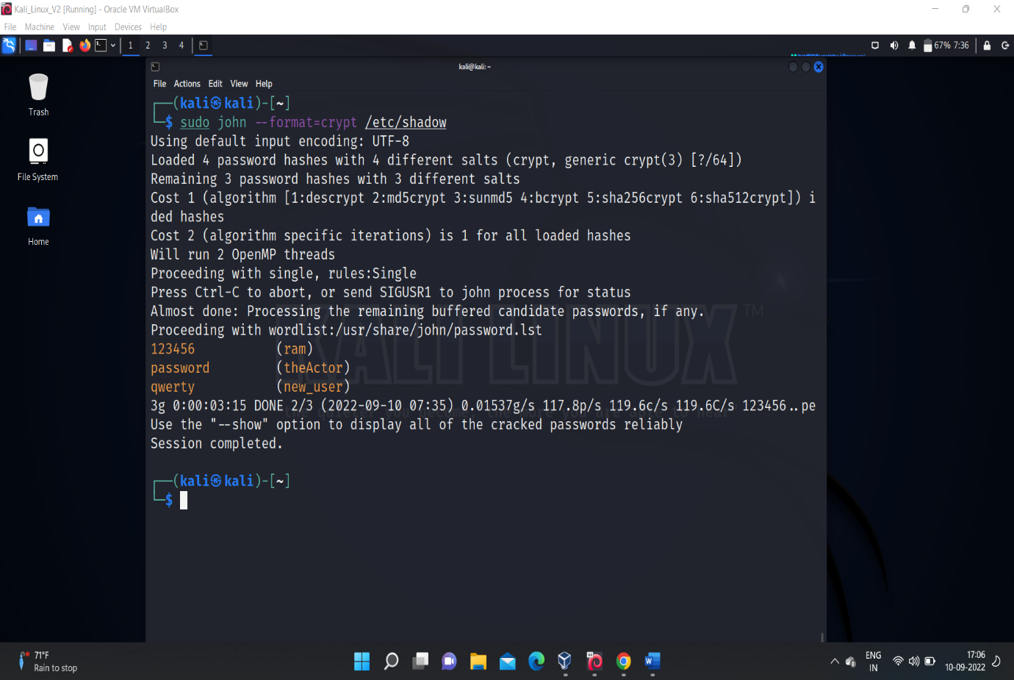

* John cracked the passwords of the users we created and showed the output .
* Since we are running with low resources of ram,and processors so for the demonstration purpose we took some small and common passwords to crack.
* But john can crack huge passwords too.

**(5)Crunch:-**

Crunch is apowerful tool it is used to generate a custamised password list that makes to crack the passwords much better and efficient way in some senarios.

>command to generate a custamised password list that takes characterset as an argument.

**$ crunch <min_size> <max_size> <characterset> -o file_name**

>In our case consider characterset be ‘eH@3’ and min=4,max=4

* then our command may look like this

**$ crunch 4 4 ‘eH@3’ -o custampasswords.txt**

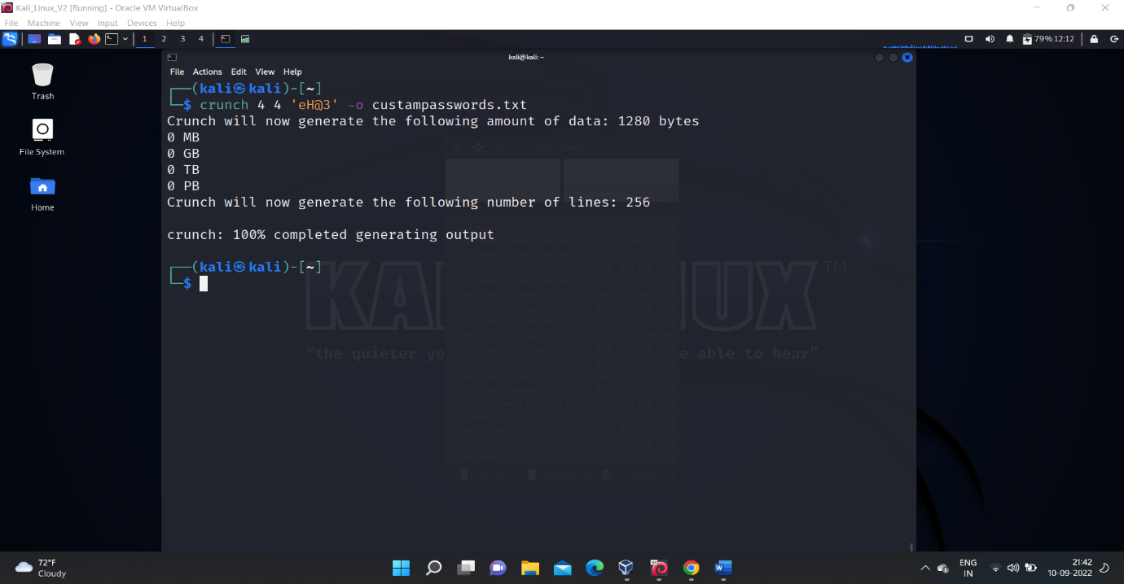

>now the generated passwords can be given to hydra to crack the password of an user.

>To prove this, in my metasploitable machine I had a user named ‘ram’ and password ‘He@3’ now lets try to crack this user account using the custamised password list generated by the crunch tool.

>To work with hydra we have to find the open port on the target machine.(open port details).

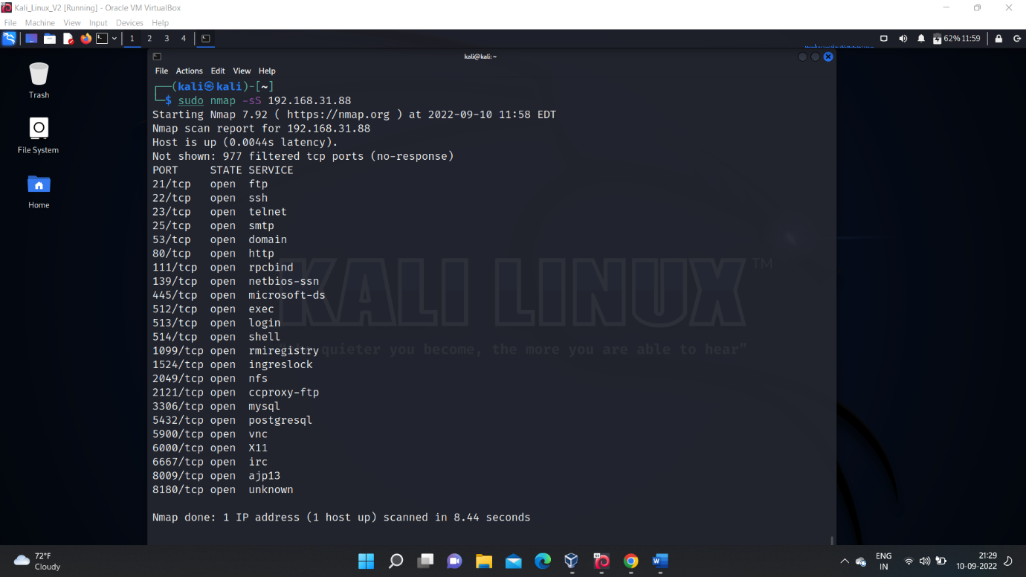

>Then using hydra and loading the custamised passwords that are generated by crunch the password for the user ‘ram’ is cracked.

>the result is shown in below screen shot.

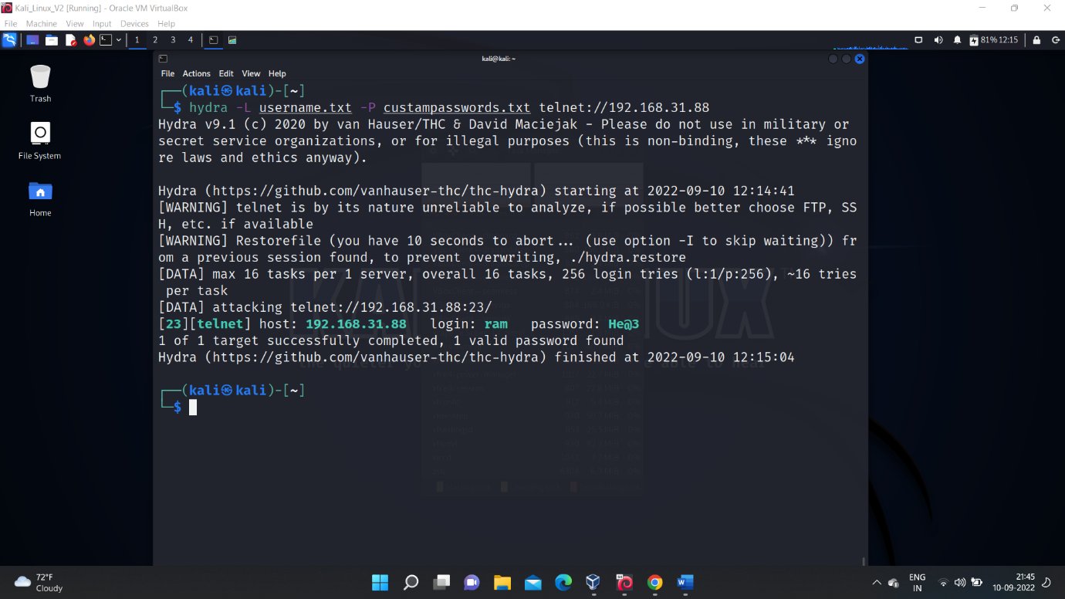

* Similarly using crunch we can also generate much custamised passwords like “at starting charcter is upper case and next 3 letters is lower then 1 character is special symbol then another 2 characters is numeric like this” .
* this way of generating custamised passwords is based on the pattern .
* , => Uppercase

@ => lowercase

^ => specialsymbol

% => digit.

Example:-

* Our pattern ,@^%

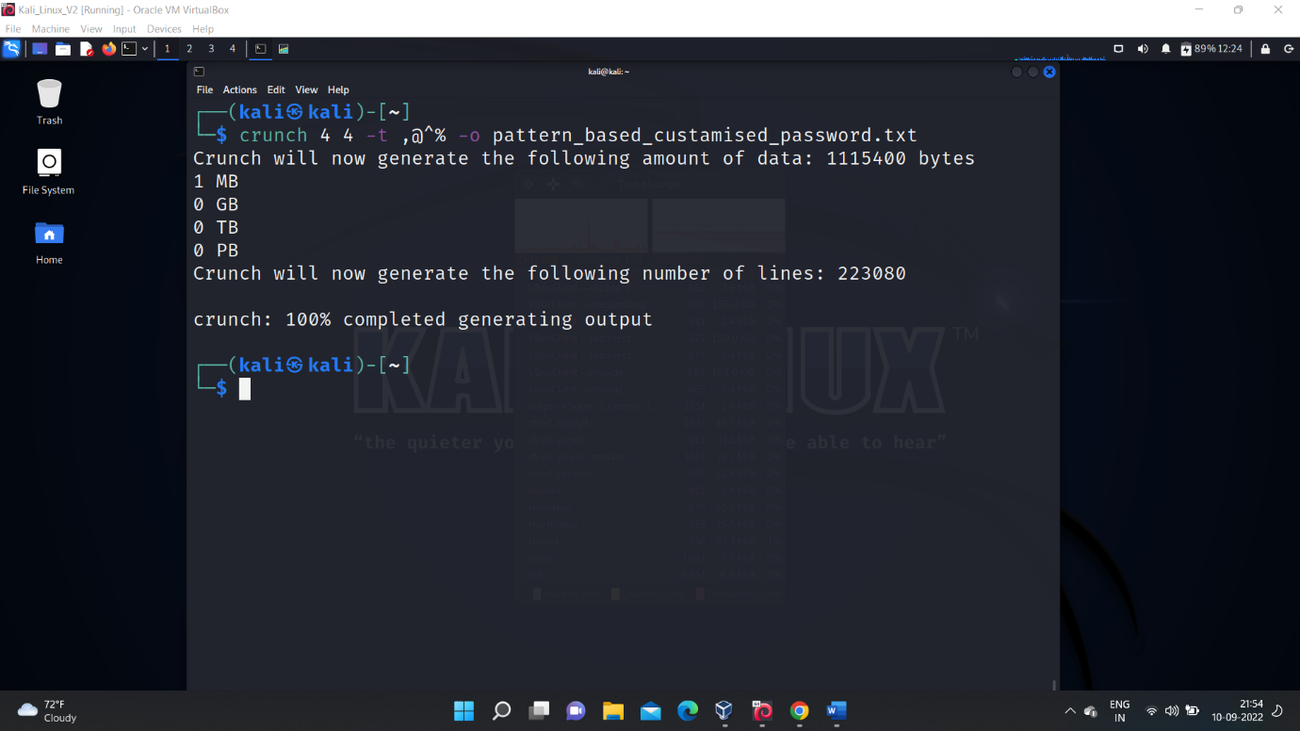

>Based on the pattern the crunch generated huge number of custamised passwords i.e 223080

> when load this password list file into the hydra and if we try to crack the password of the user it would crack but it takes so much time and needs more resources (more ram,more number of processors) to crack.

> if I try to perform the cracking using hydra and using the generated pattern_based_passwords it shows like this.

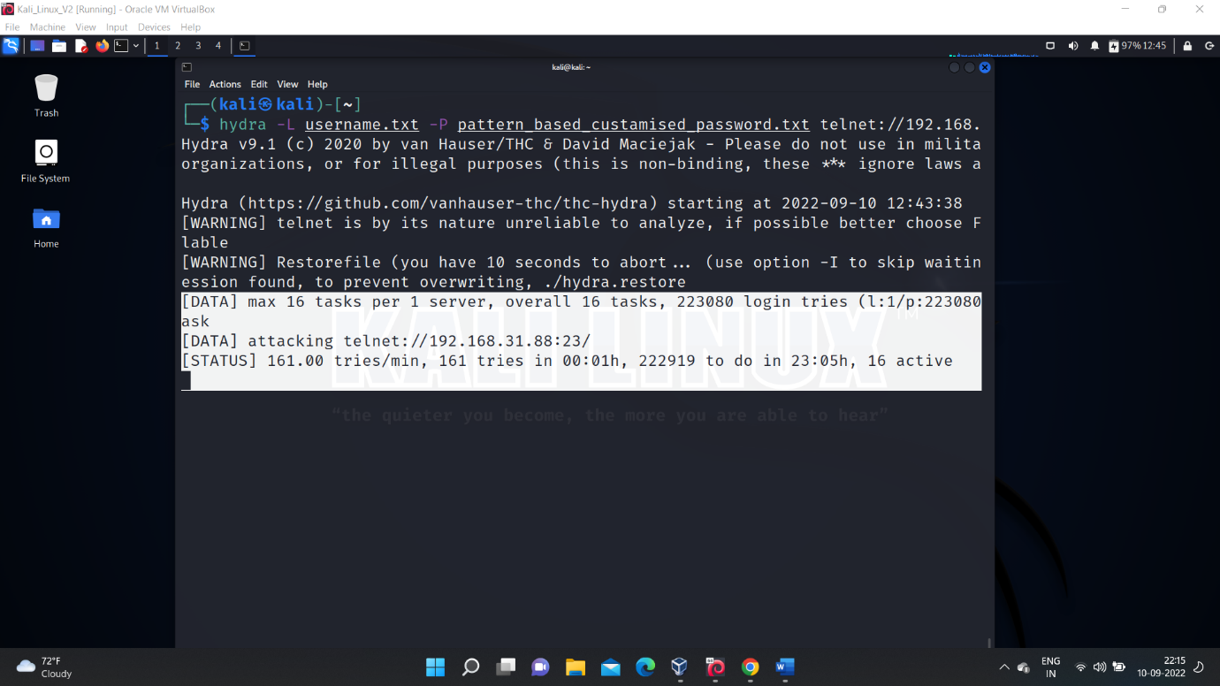

>In the above screen shot it is clear that it may takes nearly 24 hours to crack the password.

> so as the complexity of the password grows it takes more time to crack and also require more resources.

**This is all about the system hacking using**

* Hydra
* Auxiliary module
* Nse – scripts
* John the ripper
* Crunch

************